**NAME: Jumawan bin Hakim**

**ID: 05DDT16F01017**

**INTERFACE**

|  |  |  |
| --- | --- | --- |
| **First Load** |  | **Saved Button Clicked** |
|  |  |  |

­­

|  |
| --- |
| **View Button Clicked** |
|  |

**SOURCE CODE**

1. Main Activity.java

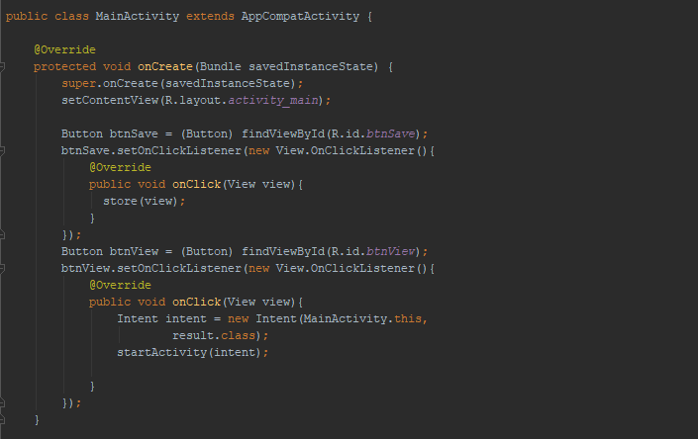

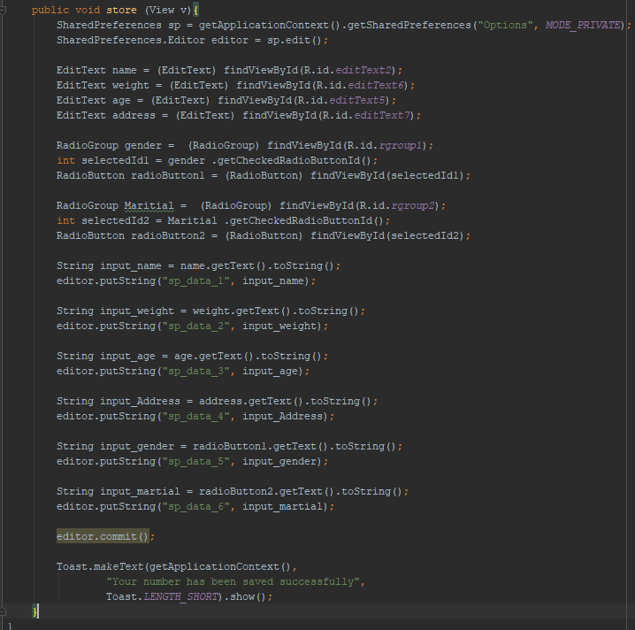

1. activity_main.xml

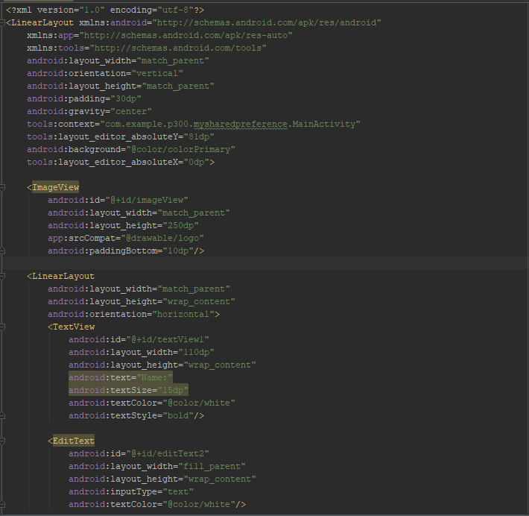

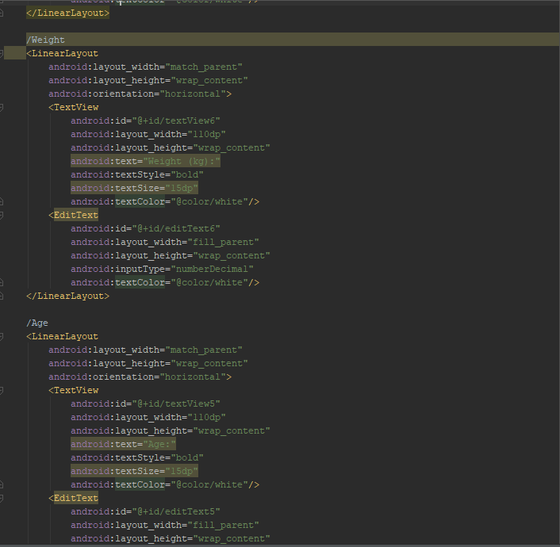

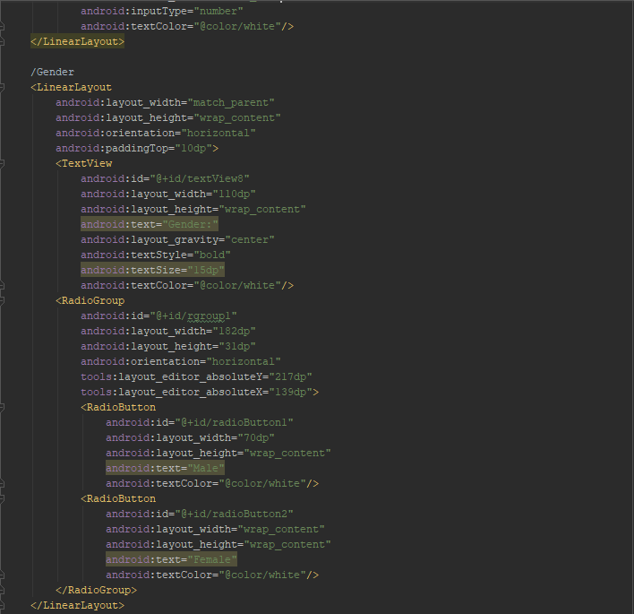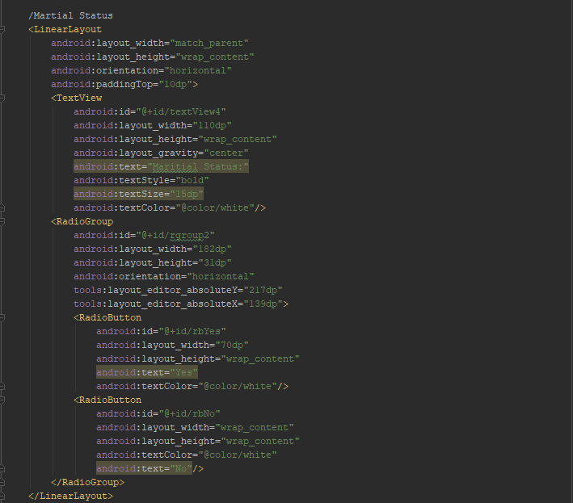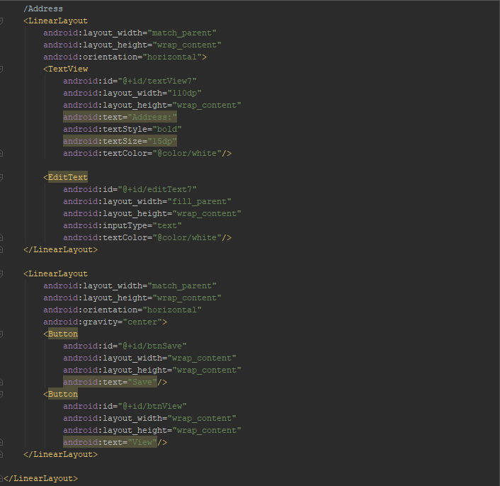

1. result.java

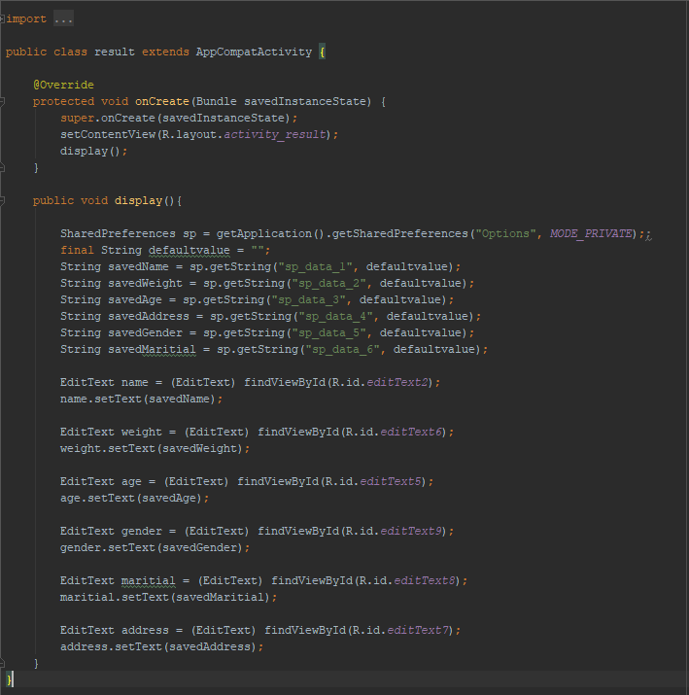

1. activity_result.xml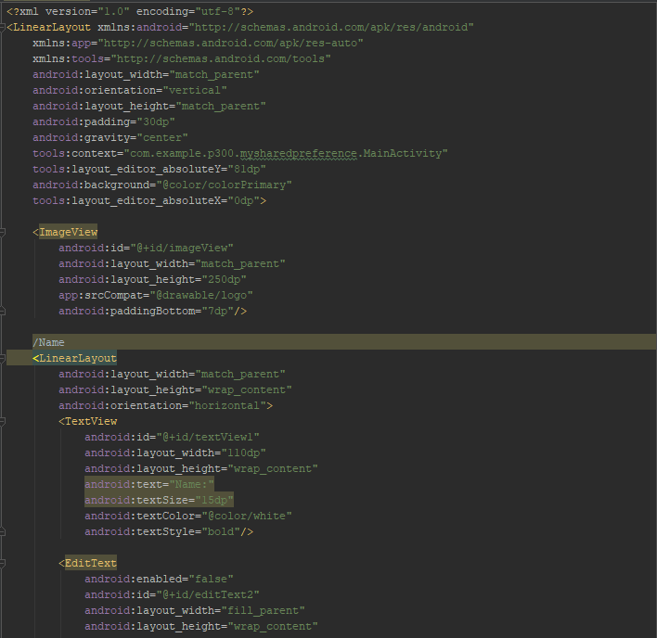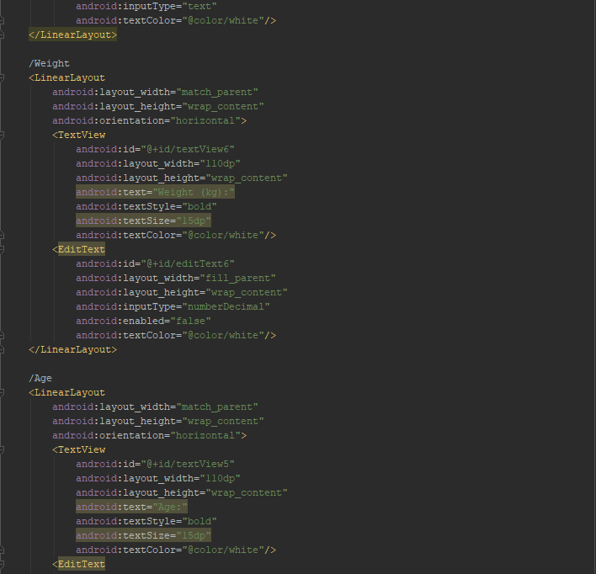

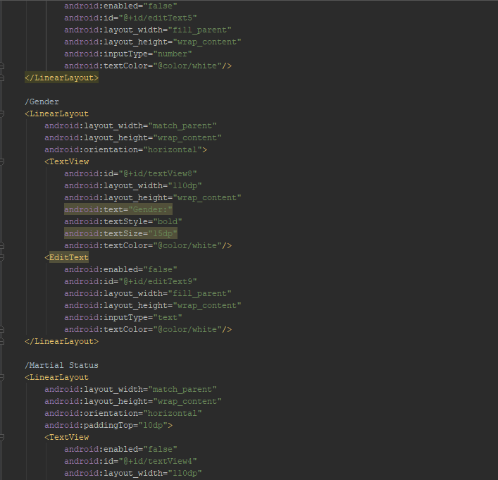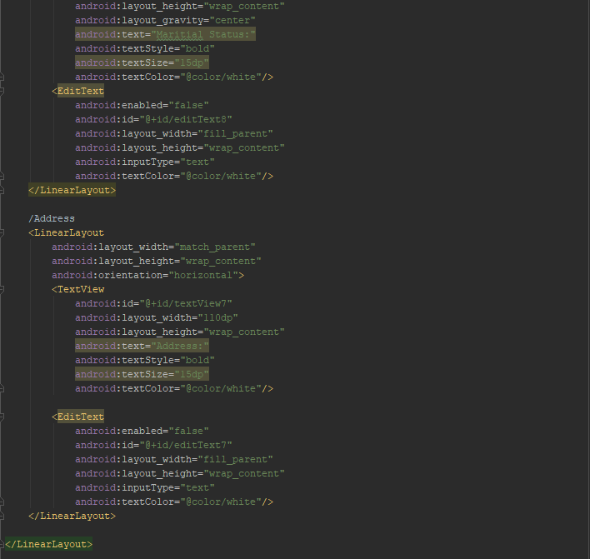

**Source Code File:** [**Click Here**](http://bit.do/MySharedPreference)